Given a binary search tree and a node in it, find the in-order successor of that node in the BST.

The successor of a node p is the node with the smallest key greater than p.val.

**Example 1:**

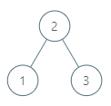

**Input:** root = [2,1,3], p = 1

**Output:** 2

**Explanation:** 1's in-order successor node is 2. Note that both p and the return value is of TreeNode type.

**Example 2:**

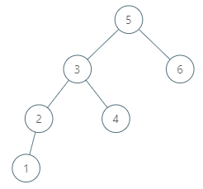

**Input:** root = [5,3,6,2,4,null,null,1], p = 6

**Output:** null

**Explanation:** There is no in-order successor of the current node, so the answer is null.

**Note:**

1. If the given node has no in-order successor in the tree, return null.
2. It's guaranteed that the values of the tree are unique.